**International Institute of Professional Studies**

**Devi Ahilya Vishwavidyalaya**

**Indore, MP, INDIA**

**2015**

**SOFTWARE DESIGN DOCUMENT**

**for**

**IIPS-DC-MIS**

**Version 1.0 approved**

**Prepared by –**

**Amarpreet Jethra**

**Himanshi Nigam**

**M.TECH(IT) 6th Sem**

**TABLE OF  CONTENTS**

**1.  INTRODUCTION**

1.1  Purpose

1.2  Scope

1.3  Overview

1.4  Reference Material

1.5  Definitions and Acronyms

**2.  SYSTEM OVERVIEW**

2.1 Technologies Used

2.2 Application Overview

2.3 Design Languages

**3.  SYSTEM ARCHITECTURE**

3.1  Architectural Design

3.2  Decomposition Description

**4. DATA  DESIGN**

4.1  Data Description

4.2  Data Dictionary

**5.  COMPONENT  DESIGN**

**6.  HUMAN  INTERFACE  DESIGN**

6.1  Overview of User Interface

6.2  Screen Images

6.3  Screen Objects and Actions

**1.  INTRODUCTION**

The Software Design Document is a document to provide documentation which will be used to aid in software development by providing the details for how the software should be built. Within the Software Design Document are narrative and graphical documentation of the software design for the project.

**1.1 PURPOSE**

This SDD defines and describes the use of each view, the architectural constraints of the system, the functional requirements with a significant impact on the architecture,  the layers and subsystems of the application, performance issues and constraints**.**

This document expands the functionality described by the features in the Software Requirements Specifications (SRS).

**1.2 SCOPE**

This document describes the implementation details of the MIS software. The scope of MIS-DC is not only about product-development but also up to the implementation and deployment,This includes the training of the various end-users and maintenance of the products.

The whole system consists of following categories of stakeholders:

Visitors: The visitors to this application can only see the basic information provided about DC.

DC members: The DC members can login and manage their profile(containing daily work log ). He/She can make changes in some areas like projects, Worklog, ongoing activities and can’t alter the contents of books available and information related to infrastructure.

Administrator:The administrator(DC incharge) can monitor performance and  add/remove DC members accordingly.

For this particular Software Design Document, the focus is placed on generation of the documents and modification of the documents.

**1.3 OVERVIEW**

The SDD is divided into 7 sections with various subsections. This SDD particularly focuses on:

1. Introduction
2. System Overview
3. System Architecture
4. Data Design
5. Component Design
6. Human Interface Design
7. Requirement Matrix

**1.4 REFERENCE MATERIAL**

* [IEEE] The applicable IEEE standards are published in “IEEE Standards Collection,”2001 edition.
* Reaves, Michael J.  “Software Project Management Plan Jacksonville State University Computing and Information Sciences Web Accessible Alumni Database.” Jacksonville State University, 2003.
* Reaves, Michael J. “Software Requirement Specifications Jacksonville State University Computing and Information Sciences Web Accessible Alumni Database.”Jacksonville State University, 2003.

**1.5 DEFINITIONS AND ACRONYMS**

* SDD - Software Design Document
* SRS - Software Requirement Specification
* SPMP - Software Project Management Plan
* MIS - Management Information System
* DC - Development Centre
* IEEE - Institute of Electrical and Electronic Engineers
* DFD – Data Flow Diagram

**2. SYSTEM OVERVIEW**

**2.1 Technologies Used**

The system is coded with php programming language which is a server side language by using sublime text editor. We will use Oracle 8i for database. Modern web browsers are required for running this web service.

**2.2 Application Overview**

The main goal of the project is to enable user to access information about DC and its resources and its DC members to manage tasks online. The final product of MIS project will be a web app that will enable visitors, dc members and its Admin to perform their specific tasks related to DC in a more handy way.This project gives the user the access to the functionalities of the web application easily. For example, MIS -DC gives opportunities to its users to apply for entrance as well as get to know about its members and their contribution. DC member can manage their profile, share knowledge on advanced technologies, apply for leave, mark their attendance, showcase their achievements.Admin have a control on overall activities going on and can add a new or remove an existing member by monitoring on their performances.

**2.3 Design Languages**

Unified Modeling Language (UML) 5.02 is used for graphical representations of viewpoints in MIS Project in 3.System Architecture, 4.Data Design and 5.Component Design parts.

**3. SYSTEM ARCHITECTURE**

**3.1 Architectural Design**

The architectural design is explained by the level 0 Data Flow Diagram shown below that involves three entities : Admin,DC member and visitor. The relationship between them is shown by arrows that includes common process of DC Management Information System.

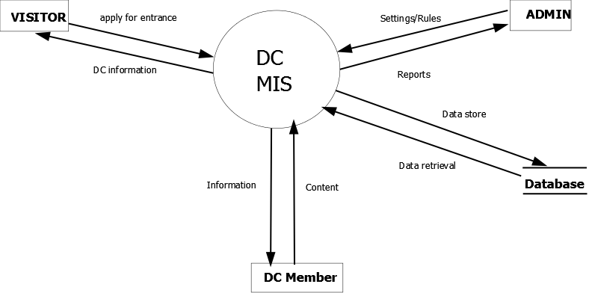

**Level 0 DFD**

**3.2 Decomposition Description**

The above process is further decomposed into subprocesses that are explained by level 1 DFD shown below.

**Part I Level 1 DFD**

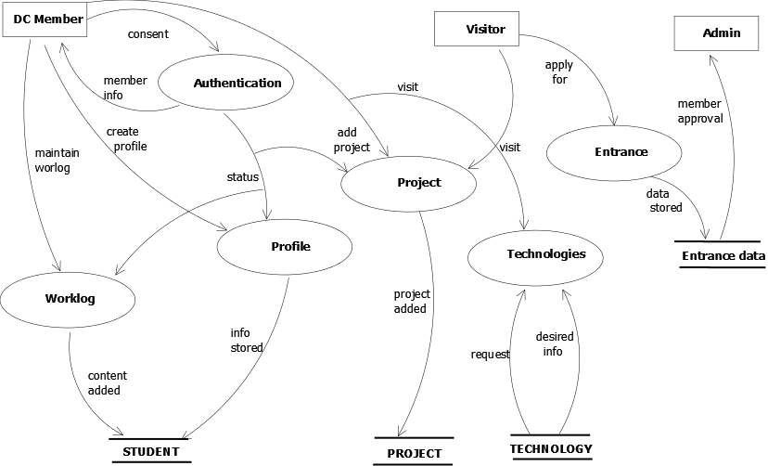

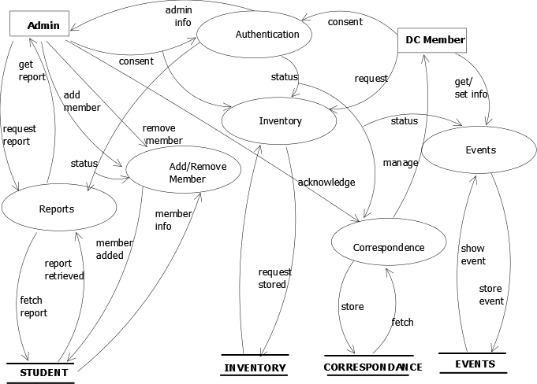

**Part II Level 1 DFD**

**4. DATA DESIGN**

**4.1 Data Description**

Database used for this system is phpMyadmin.Following tables are constructed :

* **achievements -** It shows the achievements of the dc members and involves attributes such as member_id and its achievement.
* **alumni -** It shows the details about past dc members ,and includes attributes such as  name, year_of_passing and occupation.
* **alumni_status -** It shows the status of alumni.
* **assignment -** It shows the details about the assignments given to the dc members.
* **attendance -** It shows the attendance marked by the dc member.
* **daily_log -** It shows the daily work done by the dc member along with their link.
* **dc_member -** It shows the information about the dc_member .
* **dc_member_master -** It shows the information i.e. permanent for each DC-member.
* **dc_member_regular -** It shows the information that can be altered if required for each member.
* **dc_member_social -** It shows all the information about social networking links for each member.
* **documentation -** It shows the links of SRS, SDD, SPMP of member’s project.
* **entrance -** It shows each and every detail of a new comer for entrance in DC.
* **events -** It shows the information about the events like their type, venue, date etc**.**
* **hosting_domain/issued_resource_to** -It displays the details of resources that areissued along with their issue_date and submission_date.
* **knowledge_center -** It provides a platform for sharing any kind of knowledge by any member.
* **leave -** It shows information regarding leave such as leaving_date, coming_date, reason of leave etc.
* **moocs -** It shows information related to moocs.
* **organizer -** It shows the details about the event(presentation, seminar, workshop) organizer.
* **problem_solved_by -** It shows the name of the person who solved a particular problem with its problem id.
* **project -** It shows each details about the projects going on in DC having information like project_id, type, leader, status etc.
* **project_review -** It shows information about project review like project name, review date,review by etc.
* **project_status -** It shows status of each  project with project id and status id.
* **publication -** It shows all the information associated with publishing a paper such as organizer_name, sponsers_name , year_of_publication etc.
* **resource -** It shows all the details about resources of DC with resource_id and resource_name.
* **responsibility_duration -** It shows the of responsibilities given to members with member_id ,assigned_duty ,resigned_duty.
* **result -** It contains all the information of the regular tests that are conducted in DC such as test_type and result associated with it.
* **roles_and_responsibilities -** It shows roles of each member in each department.
* **system_information -** It shows all the information related to h/w as well as s/w.
* **tags -** It shows information about all tags associated with each member.
* **team_members -** It shows all the information about the members in a particular team.
* **technical_and_motivational -** It shows technical as well as motivational issues with titles and description along with their links and tags.
* **technical_assistance -** It shows problems related to technical issues and the solution provided to solve them.

**4.2 Data Dictionary**

**1. Table for achievements**

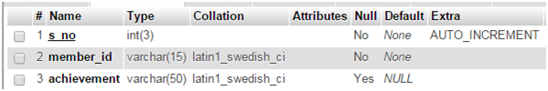

**2.Table for alumni**

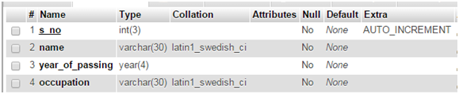

**3. Table for alumni_status**

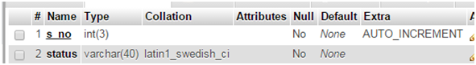

**4. Table for assignment**

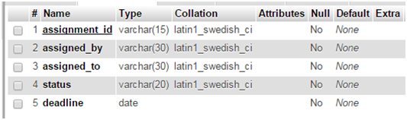

**5.  Table for attendance**

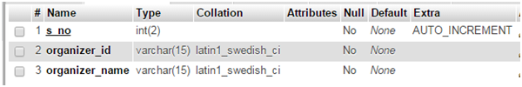

**6. Table for daily_log**

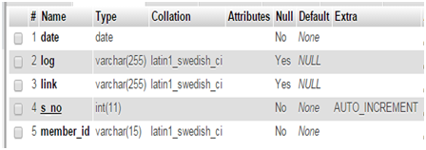

**7. Table for dc_member**

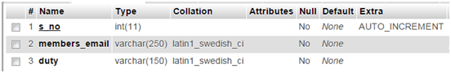

**8. Table for dc_member_master**

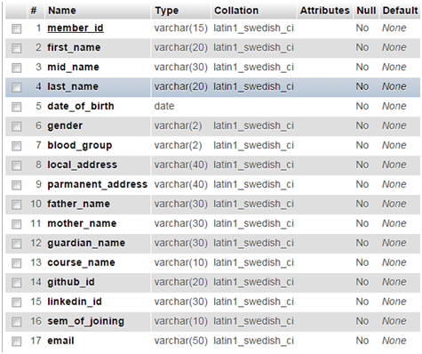

**9. Table for dc_member_regular**

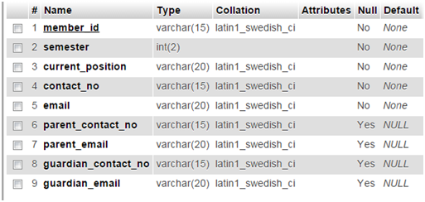

**10. Table for dc_member_social**

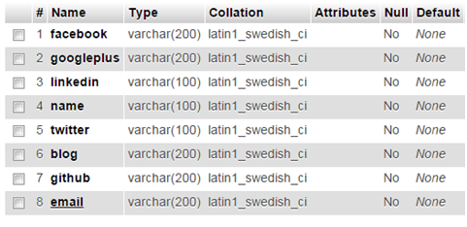

**11. Table for documentation**

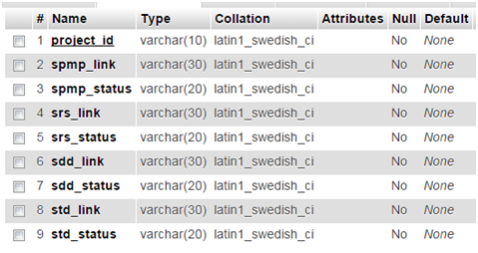

**12. Table for entrance**

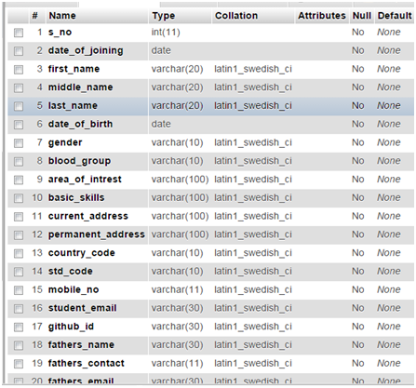

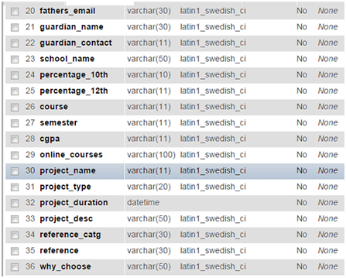

**13. Table for events**

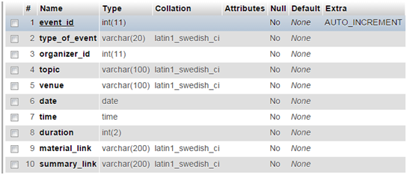

**14. Table for hosting_domain**

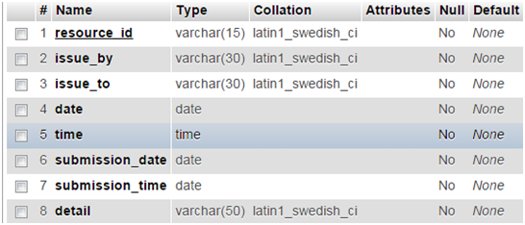

**15. Table for issued_resource_to**

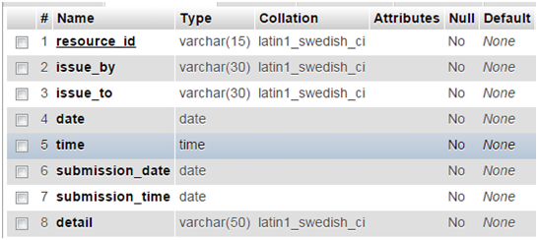

**16. Table for knowledge_center**

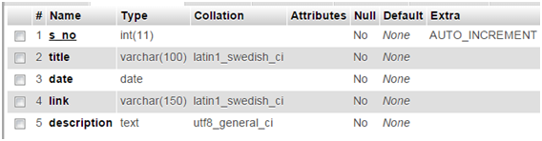

**17. Table for leave**

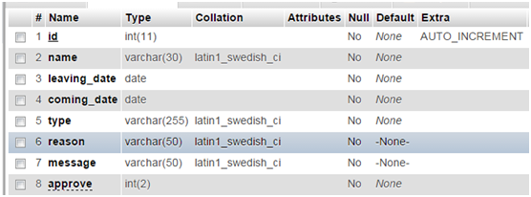

**18. Table for moocs**

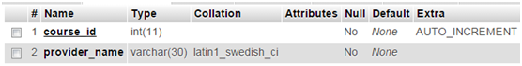

**19. Table for organizer**

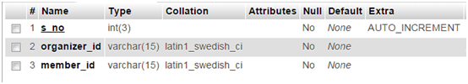

**20. Table for problem_solved_by**

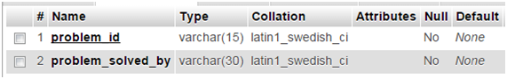

**21. Table for projects**

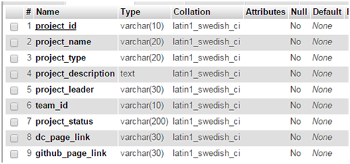

**22. Table for project_review**

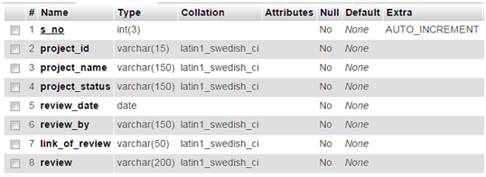

**23. Table for project_status**

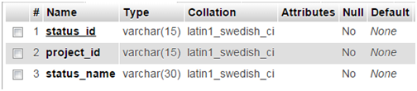

**24. Table for publication**

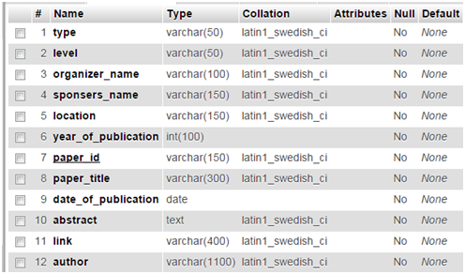

**25. Table for resource**

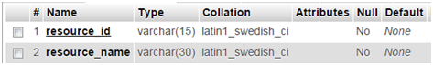

**26. Table for responsiblity_duration**

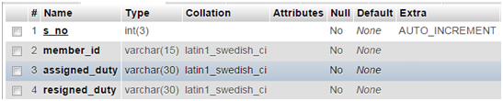

**27. Table for result**

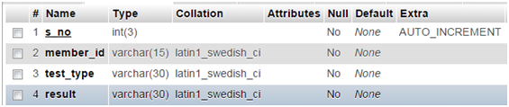

**28. Table for roles_and_resposibility**

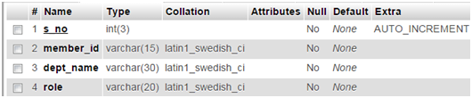

**29. Table for system_information**

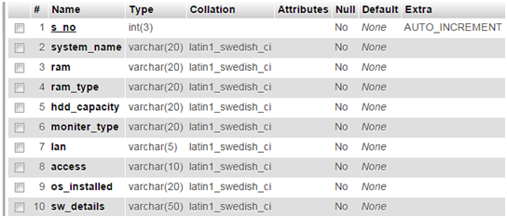

**30. Table for tags**

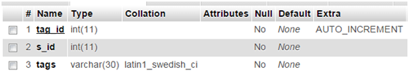

**31. Table for team_members**

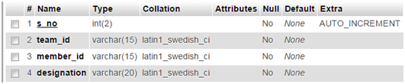

**32. Table for technical_and_motivational**

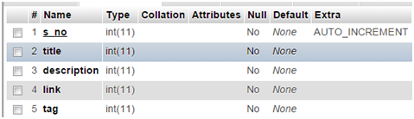

**33. Table for technical_assistance**

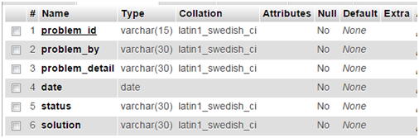

**5. COMPONENT DESIGN**

“Users with appropriate permission” in the diagram refers to the users who are given exemptions or/and users of a particular level. Precise permissions are listed in SRS.

We can explain the system requirements on the basis of the sequence diagrams for individual user.

**5.1 ADMIN**

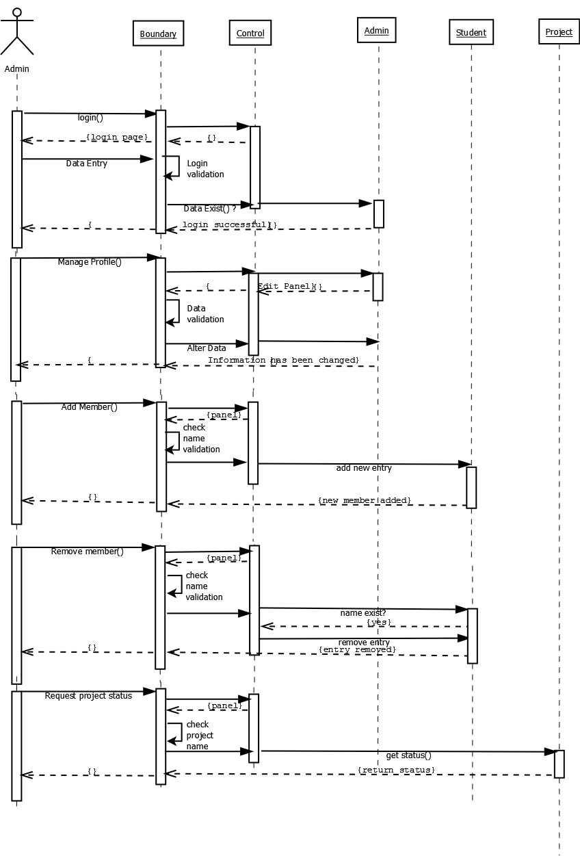

**5.2 DC MEMBER**

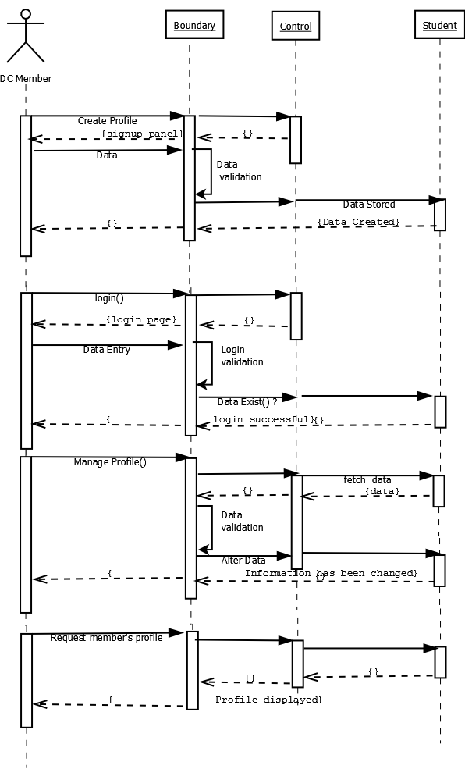

**5.3 VISITORS**

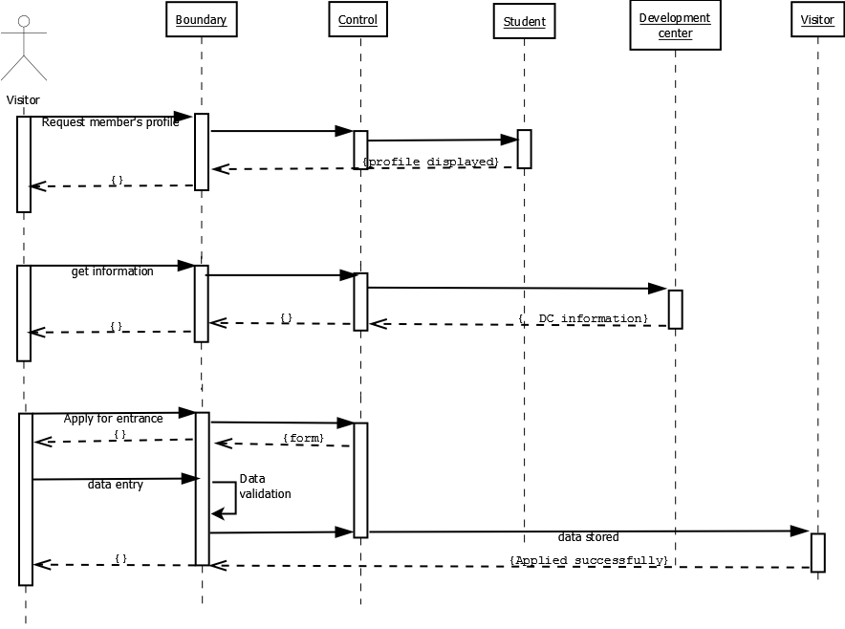

**6. HUMAN INTERFACE DESIGN**

**6.1 Overview of User Interface**

UI is designed according to UI design principles.

**The structure principle**: UI is organized in such a way that related things are combined together and unrelated things are separated.

**The simplicity principle:** It is easy to follow the provided interface. In  the case of mistake, system displays error message.

**The visibility principle:** All system‟s functions are available through UI. It does not overwhelm users with too many alternatives.

**The feedback principle:** Through the system of messages, the design keeps users informed of actions, errors, or exceptions.

**The reuse principle:** In design, same names were used to perform the same operations with different objects in order to reduce ambiguity.

**6.1.1. Web pages in a tree**

The system’s web pages are presented in a tree. From “Home” page user can reach “About us” , “DC Members”, ”Open Source”, “Projects”, ”Login” pages. From “DC Members” page user can reach following pages: “Current Members”, “Past Members”. From “Projects” page user can reach “Current Projects” and “Past Projects”. From “Open Source” page user can get following information about technologies like “Linux”, “Python”, “node.js” “PHP”, “Mozilla”, “Git”, “Github”, “Moodle”. All these pages cover necessary functionality of system. It is easy to navigate between these pages. User constantly has access to it through the menu on the top side of page.

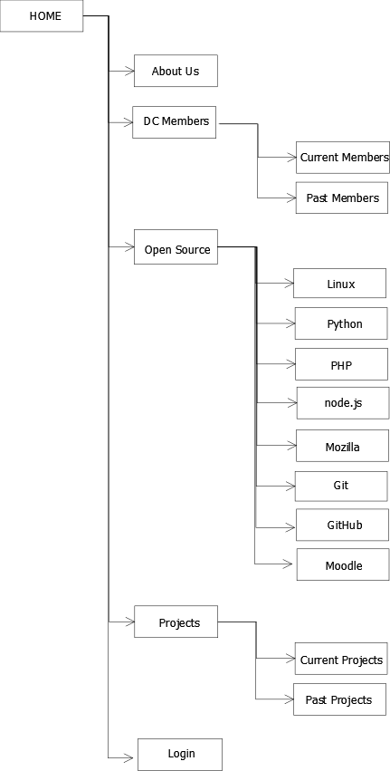

**Tree Diagram For User Interface**

**DESCRIPTION**

**“Home”** page has descriptive characters; it contains a list of main system‟s functionality and contact information. After login “Home” page changes and guides user on how to work with system.

**“About us”**page link is being provided on the top of the home page.This page consists of the History of DC and other information related to DC.

**“Open Source”**page link is being provided on the top of the home page.This page describes what is open source and some famous open source services.

**“DC Members”**page link is being provided on the top of the home page.This page contains information about current and past DC members and their contact details.

**“Projects”** page contains the past and current projects of IIPS DC and their corresponding links.

**“Login”** page provides the authorization to access DC website. This facility is only applicable for DC members and admin.

The bottom of **“Home”** page contains the mission, scope and objective of Development Center.

**6.2 Screen Images**

**6.2.1 Home Screen**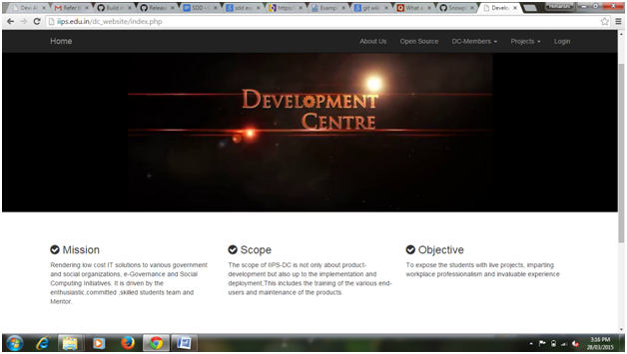

6.2.2 About Us

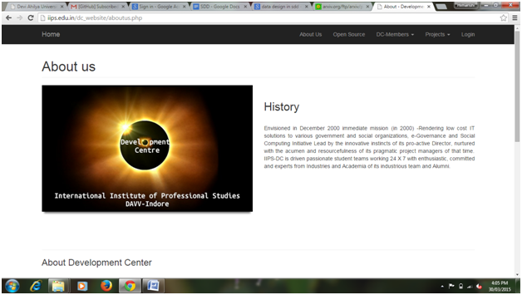

6.2.3 Opensource

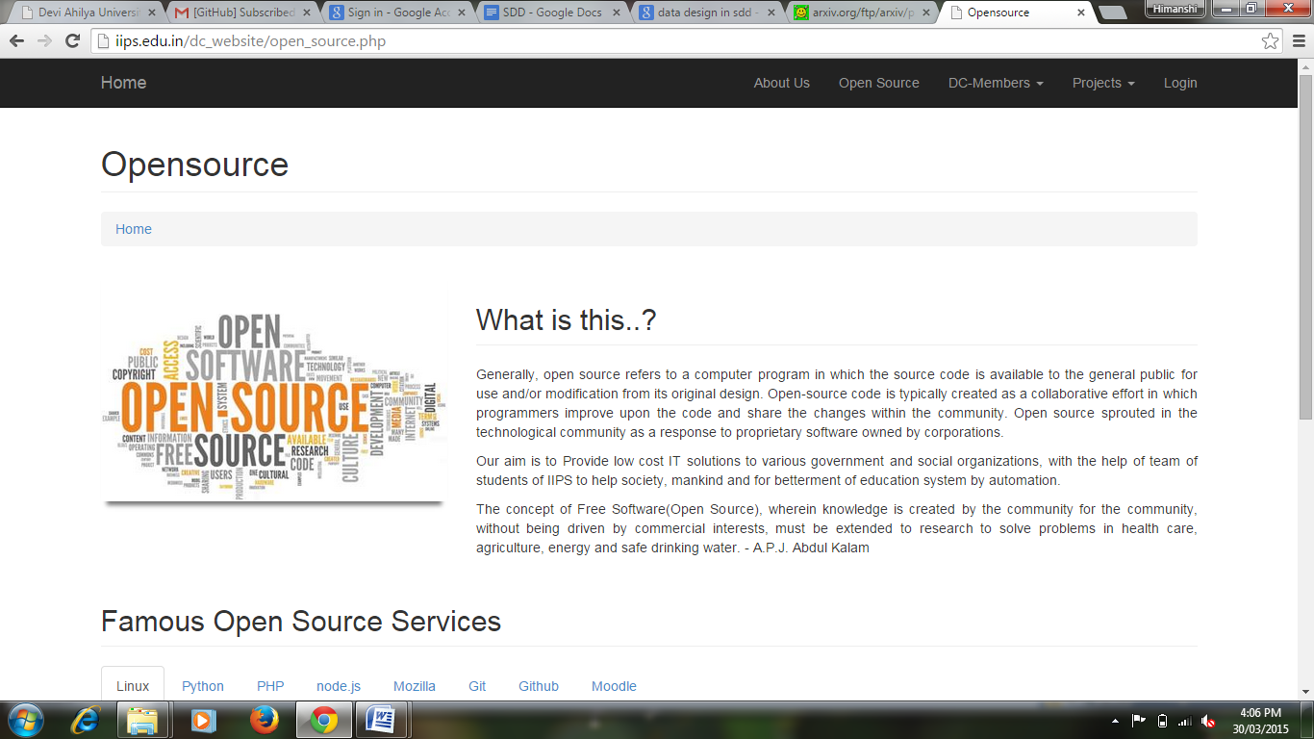

6.2.4 Current DC Members

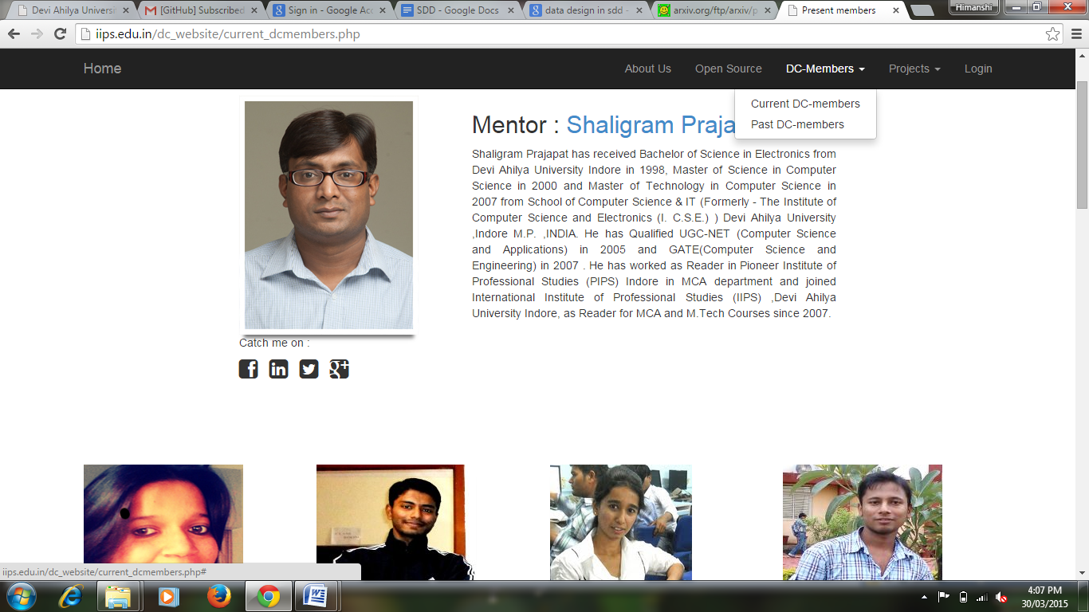

6.2.5 Past DC Members

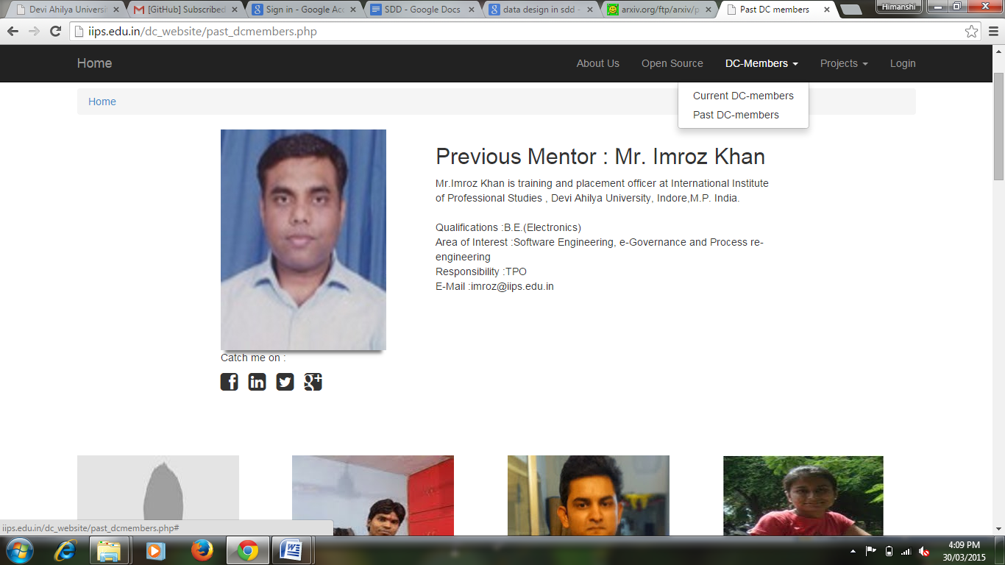

6.2.6 Current DC Projects

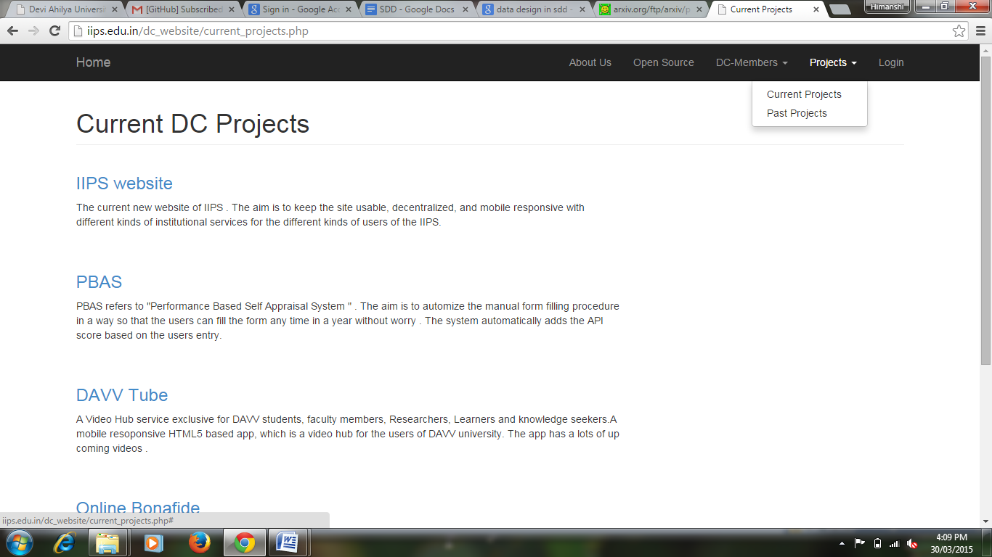

6.2.7 Past DC Projects

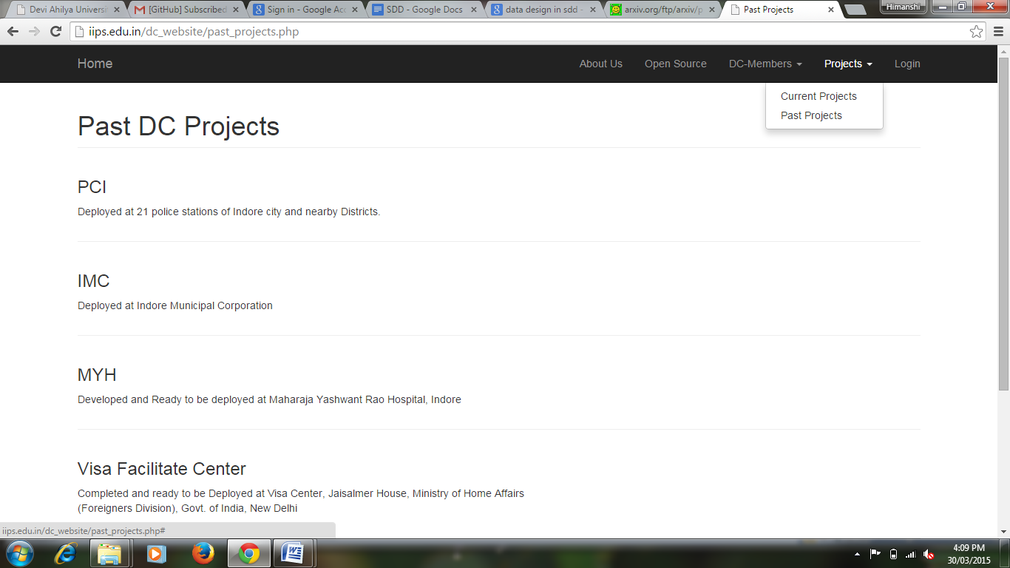

**6.3 Screen Objects and Actions**

In the **“Login”** page user provides login and password in appropriate text boxes and confirms this operation, clicking on button “Submit”. For high privileged users system will ask to provide

unique id and password.

After logging “Dashboard” page is available to DC member. It contains following menu: “Profile”, “Publications”, “Knowledge Centre”, “Events”, “Projects”, “Leave”, “Infrastructure” and “Logout”. User clicks on necessary item in the menu in order to transfer in the next page.